***ER Diagram - 02***

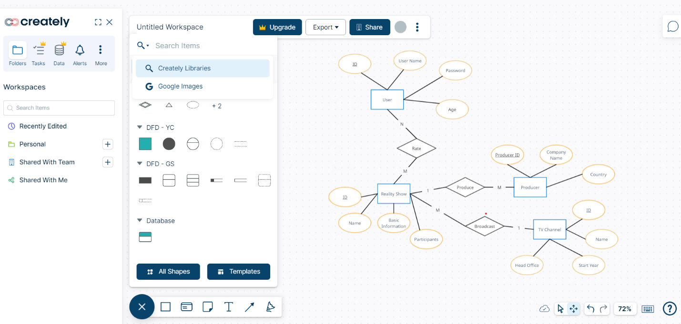Scenario 01

Scenario 02

